**Contents**

**JAVASCRIPT**

**Functions:**

* **Introduction:**
* **Programming Question: travel agency vehicle count**
* **Code:**

let vehicles = {

"SUV" : 10,

"Sedan" : 27,

"Luxury" : 5

};

function travelAgency(vehicleType) {

if (vehicles[vehicleType] != undefined) {

console.log(`We provide ${vehicles[vehicleType]} vehicles of the type ${vehicleType}.`);

} else {

console.log('Sorry. We only provide the following types of vehicle:');

for (var key in vehicles) {

console.log(key);

}

}

}

travelAgency("SUV");

travelAgency("Sedan");

travelAgency("Luxury");

travelAgency("Hatchback");

* **Output:**

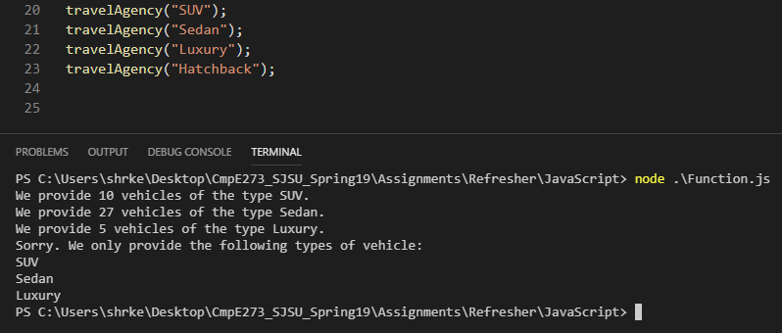

**Events:**

* **Introduction:**
* **Programming Question: button colour change on click event**
* **Code:**

<!DOCTYPE html>

<html>

<head>

<script>

function decimalToHex(decimal) {

hex = decimal.toString(16);

if (hex.length % 2) {

hex = '0' + hex;

}

return hex;

}

function randomColourHexValue() {

var decimalValue = Math.random() * 255;

decimalValue = Math.floor(decimalValue);

var hexValue = decimalToHex(decimalValue);

return hexValue;

}

function setColor(button) {

var red = randomColourHexValue();

var green = randomColourHexValue();

var blue = randomColourHexValue();

var property = document.getElementById(button);

property.style.backgroundColor = `#${red}${blue}${green}`;

alert('Colour changed!');

}

</script>

</head>

<body>

<input type="button" id="button" value = "Click me to change my colour!" style= "color : black" onclick="setColor('button')";/>

</body>

</html>

* **Output:**

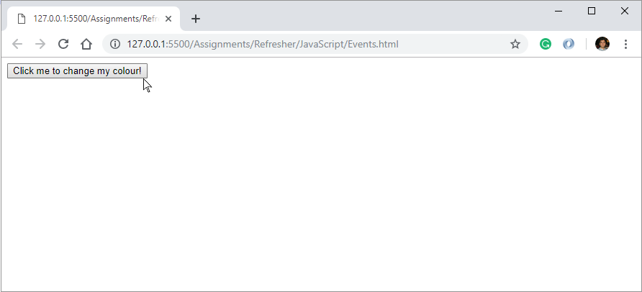

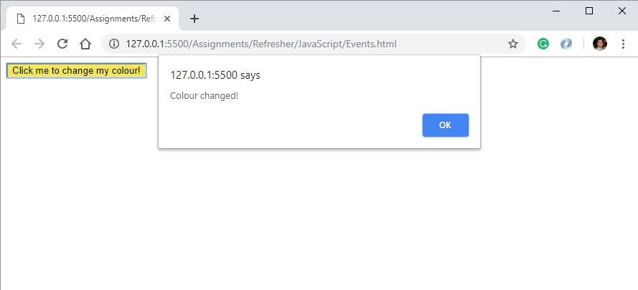

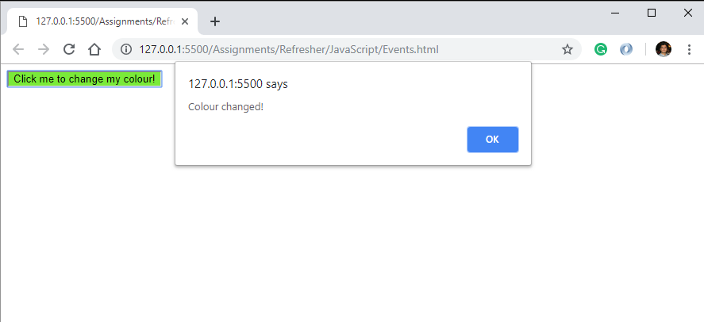

**Arrays:**

* **Introduction:**
* **Programming Question: male and female candidates in exam**
* **Code:**

let candidates = {

"John" : "M",

"Alexa" : "F",

"Bryan" : "M",

"Cindy" : "F",

"Roy" : "M",

"Evan" : "M"

};

let male = [];

let female = [];

for (key in candidates) {

if(candidates[key] == "M") {

male.push(key);

} else if (candidates[key] == "F") {

female.push(key);

}

}

console.log("The male candidates are:", male);

console.log("The female candidates are:", female);

* **Output:**

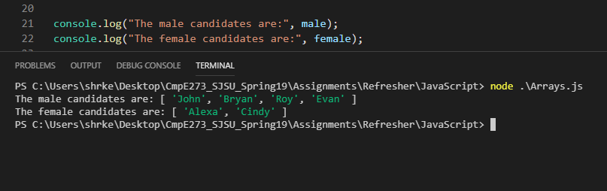

**Regular Expressions:**

* **Introduction:**
* **Programming Question: check email id and convert to sjsu edu**
* **Code:**

function emailValidity(emailId) {

let checkEmail = emailId.match(/\S+@\S+/);

let validity = checkEmail? 'valid' : 'invalid';

console.log(`The email id is ${validity}`);

return validity;

}

function convertToEdu(emailId = 'xyz') {

if(emailValidity(emailId) == 'valid') {

let regex = '[^@]*$';

let convertThis = emailId.match(regex);

let eduId = emailId.replace(convertThis[0],'sjsu.edu');

console.log(`New SJSU Edu ID for the student is ${eduId}`);

} else {

console.log('Please enter a valid email id.');

}

}

convertToEdu('john.doe@yahoo.com');

convertToEdu('jeffsmith92gmail.com');

convertToEdu();

* **Output:**

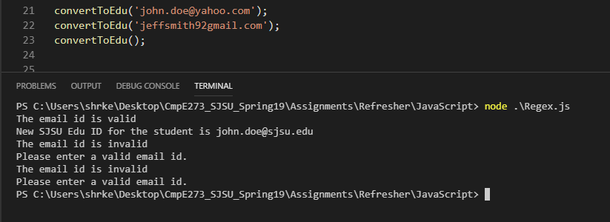

**Strict mode:**

* **Introduction:**
* **Programming Question:**
* **Code:**
* **Output:**

**Errors:**

* **Introduction:**
* **Programming Question:**
* **Code:**
* **Output:**

**Default Params:**

* **Introduction:**
* **Programming Question:**
* **Code:**
* **Output:**

**Includes and typeof:**

* **Introduction:**
* **Programming Question:**
* **Code:**
* **Output:**

**Use of import and export:**

* **Introduction:**
* **Programming Question:**
* **Code:**
* **Output:**

**Type Conversions:**

* **Introduction:**
* **Programming Question:**
* **Code:**
* **Output:**

**JSON:**

* **Introduction:**
* **Programming Question:**
* **Code:**
* **Output:**

**Object and Classes:**

* **Introduction:**
* **Programming Question:**
* **Code:**
* **Output:**

**Object.assign:**

* **Introduction:**
* **Programming Question:**
* **Code:**
* **Output:**

**Static method:**

* **Introduction:**
* **Programming Question:**
* **Code:**
* **Output:**

**Inheritance using sub-classes in JavaScript.:**

* **Introduction:**
* **Programming Question:**
* **Code:**
* **Output:**

**Method overriding:**

* **Introduction:**
* **Programming Question:**
* **Code:**
* **Output:**

**Use of get (In Classes):**

* **Introduction:**
* **Programming Question:**
* **Code:**
* **Output:**

**fetch() ( Use any open-source API for fetching data):**

* **Introduction:**
* **Programming Question:**
* **Code:**
* **Output:**

**HTML5**

**Local Storage:**

* **Introduction:**
* **Programming Question:**
* **Code:**
* **Output:**

**Media (Video and Audio):**

* **Introduction:**
* **Programming Question:**
* **Code:**
* **Output:**

**Input Type (make use of different input property options in HTML5 like patterns, autofocus, required, email etc. Place types you want, mention the properties used in your Introduction to Topic section):**

* **Introduction:**
* **Programming Question:**
* **Code:**
* **Output:**

**Geolocation:**

* **Introduction:**
* **Programming Question:**
* **Code:**
* **Output:**

**JAVA** **(Use JUnit Framework for testing the application):**

**Queues:**

* **Introduction:**
* **Programming Question:**
* **Code:**
* **Output:**

**Stacks:**

* **Introduction:**
* **Programming Question:**
* **Code:**
* **Output:**

**Arrays:**

* **Introduction:**
* **Programming Question:**
* **Code:**
* **Output:**

**Interfaces:**

* **Introduction:**
* **Programming Question:**
* **Code:**
* **Output:**

**Collections:**

* **Introduction:**
* **Programming Question:**
* **Code:**
* **Output:**

**Generics:**

* **Introduction:**
* **Programming Question:**
* **Code:**
* **Output:**

**Multithreading:**

* **Introduction:**
* **Programming Question:**
* **Code:**
* **Output:**